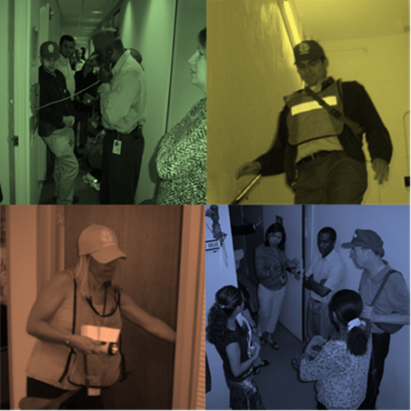  CEPP TRAINING Courses  Create emergency response plans that don’t just sit on the shelf in binders! We will train you how to create all hazard emergency plans that are comprehensive and skills based.  Nov 16 or Dec 12, 2017: 8:30am-11:30am $350  CEPP 100: Creating a Fire and Life Safety Plan  This program is 3 hours long and will include templates and instructions on how to create or strengthen your own emergency response plans.  Nov 16 or Dec 12, 2017: 12:30-2:30pm $200  CEPP 201: Volunteer Team Training and Development (Floor Warden Training)  The program is 2 hours long and will include skills based training on how to create, engage and train your own floor warden team.  Nov 16 or Dec 12, 2017: 2:30-4:30pm $200  CEPP 202: Employee Preparedness  The program is 2 hours long and will teach you how to prepare your employees for disasters in the workplace. You will be given our suite of tools to prepare your floor evacuation plans and building evacuation guidelines for your employees and occupants.  Stay for all three classes for a reduced total cost of $600.  All training will be conducted by Tom Davis, CPP, President of Corporate Emergency Preparedness Solutions, LLC, a Safety and Security consulting firm that specializes in helping businesses prepare their firms for emergencies. Mr. Davis is the former Director of Safety and Security at TIAA, who led the development of the firm’s enterprise wide Employee Preparedness Program. | 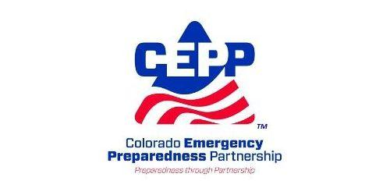Strengthen your Emergency Response Plans  ────  Work towards Fire Code and NFPA 1600 requirements  Create and Train Your Own Volunteer Emergency Response Team (VERT)  Prepare Tenants and Occupants For All Hazards  To register, please visit CEPP’s Website or contact Pat Williams at info@thecepp.org.

